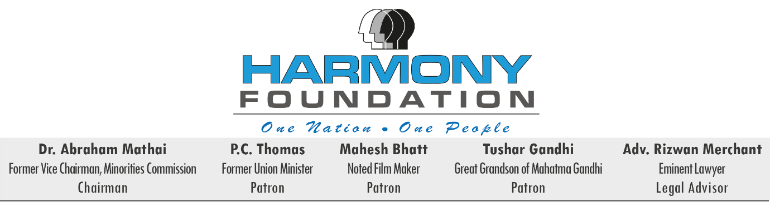

Press Release 20th April 2018

How safe are our daughters? Who will save the girl child?
Teenage girls express their angst against the unabated rape in the country
#ProtectHerEmpowerHer
It is despicable that rapes continue to take place with impunity in the world’s largest democracy. The Kathua, Unnao, Surat and Etah and countless other unreported cases are such ugly blots to our Constitution which upholds the strength and character of our nation.
How safe are our daughters as the world commemorates this year the 70th Anniversary of the Universal Declaration of Human Rights? Who will protect the girl child from sexual violence and gruesome abuse of overwhelming magnitudes?
Several political parties have turned out the most burning issue into the arena of trading allegations by turning a tragedy of our times into a political blame game, yet the real problem demanding our urgent attention seriously needs to be addressed at the core. Such barbaric and shameful acts are diametrically opposite to the noble initiative of Beti Bachao Beti Padao as they continue to take place unabated and with impunity.
What is inexplicable is the support for the perpetrators of this gruesome crime as if the vulnerable sections of society are not our own children. If this was my child, would I remain silent and indifferent? Would I protect those who I so actively protect now?

The nation is witnessing an ever increasing, unchecked sexual crimes against the girl child due to the lack of fear as the ratio of conviction is dismal. In view of the prevailing scenario, death penalty should be made mandatory along with a fast track trial within six months, as deterrence for those who rape minors so that the safety and protection of the girl child can be safeguarded and ensured.

As advocacy groups and civil society joined hands all over to hold rallies and candle-light marches nationwide and globally to protest against the rape of underage minor girls in Kathua, Unnao, Surat, Etah and countless other unreported cases expressing outrage at the horrific incidents and demanding swift justice, Harmony Foundation convened a press conference to provide a platform for these young girls to voice fears and apprehensions concerning their safety and to demand stringent laws to protect them. Today the teenage girl students voiced the unexpressed anguish, agony and trauma on behalf of the unseen and unheard stigmatised girl child in the remotest parts of our country.

Prominent and distinguished voices from various spectrum of public life were present- Justice Abhay Thipsay (Retd High Court Judge), M. N. Singh (Retd Police Commissioner) Adv Rizwan Merchant (Noted Criminal Lawyer), Adv Dhiraj Mirajkar (Special Public Prosecutor), Adv Nilofer Akhtar (Noted Woman Rights Lawyer), Ms. Daisy Irani (Veteran Bollywood Actor) and Trisha Shetty (Young Social Activist). They presented their views about imposing stringent, stricter laws.

Adv Rizwan Merchant announced the “Harmony Brigade”- a panel of women lawyers formed under his guidance who will take up the cause of victims of rape all over the State, pro bono, not only to fight for justice for the victim and her family, but to guide, advise and participate in investigations by the police machinery, to ensure collection of vital evidence, including the conducting of vital forensic and medical evidence in time, which sometimes, is delayed or lost sight off, either due to lack of experience of the investigators, or due to pure negligence or occasionally due to lack of interest, so that the use of such evidence at trial will ensure and entail a conviction. Interaction between the victim and her family with such Panel of women lawyers is also a must to rehabilitate them in Society. We shall be moving the State Govt and the D.G. of Police for acceptance and recognition of this Panel of Lawyers to participate and advise on legal matters, which the inexperienced Panel of Public Prosecutors maintained by the Director of Public Prosecutions is unable to offer for various reasons. Neither the Govt nor the D.G. of Police should have any hesitation to accept this service, in as much as, we don’t intend imposing any financial burden on them, as a separate, independent and distinct corpus has been created by Mr Merchant himself, to ensure the functioning of this panel. We intend roping in at different centres many more experienced women lawyers for this legal service starting with Maharashtra and then in phases all over the country.

Dr Abraham Mathai
Founder Chairman- Harmony Foundation
Former Vice Chairman- Minorities Commission
Mobile +91-9870061184

